**SCHOOL**

**CLASS**

**Class Summary Page**

* Add Filter “Class Type” to the Class Summary Page – Done
* When AfterSchool or Breakfast selected, Class Year should be greyed out as they are not relevant - Done

**Create Class**

* Move “Class Type” ABOVE “Class Year” – Done
* If “Class Type” of “After School” ,then “Class Year” is not required, and is greyed out - DOne
* If “Class Type” of “Standard” , then “After School Type” and “After School Organisation” is not required, and is greyed out. -Done
* If “Class Type” of “Breakfast” , then “Class Year”, “After School Type” and “After School Organisation” is not required, and is greyed out - Done
* After School Organisation is missing. Please design as a dropdown option of Schools that have been registered as “Organisation” with an option to “Enter” as a text field if not on the list of values. I will provide values -- Done
* End-Date field is not mandatory for creating classes - Done

**TEACHER**

**Teacher Summary Page**

* The page cannot scroll down if there are now enteries beyond one page. Can we redesign and ensure that the “Apply” button is visible on the first page - Done
* Add “Class Type” as a Filter - Done
* Move ”Add Teacher” to the top of the page – Done
* Please show the “Entered ID Number” and not Teacher Systems Generated Unique ID Number”. Is it better is change “ID No” to “Teacher Number” to make it clearer -- Done

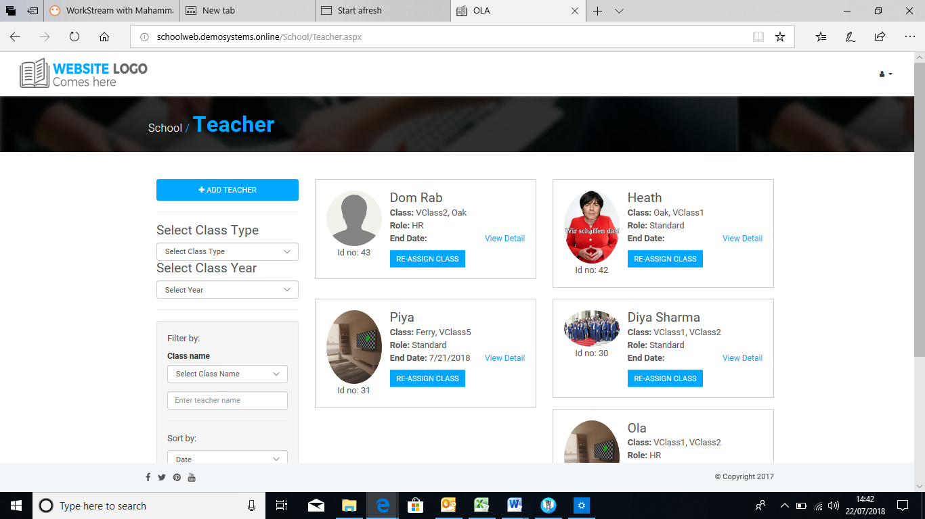

**Edit Teacher Page**

* Add “Change Password” button - Done

**Re-assign Teacher**

* Only one “Re-assign” is required from the classes assigned to the Teacher. The others can be left without changing -- Done
* The first dropdown has no values if “Re-assign2 button is selected from Teacher Summary Page -- Done

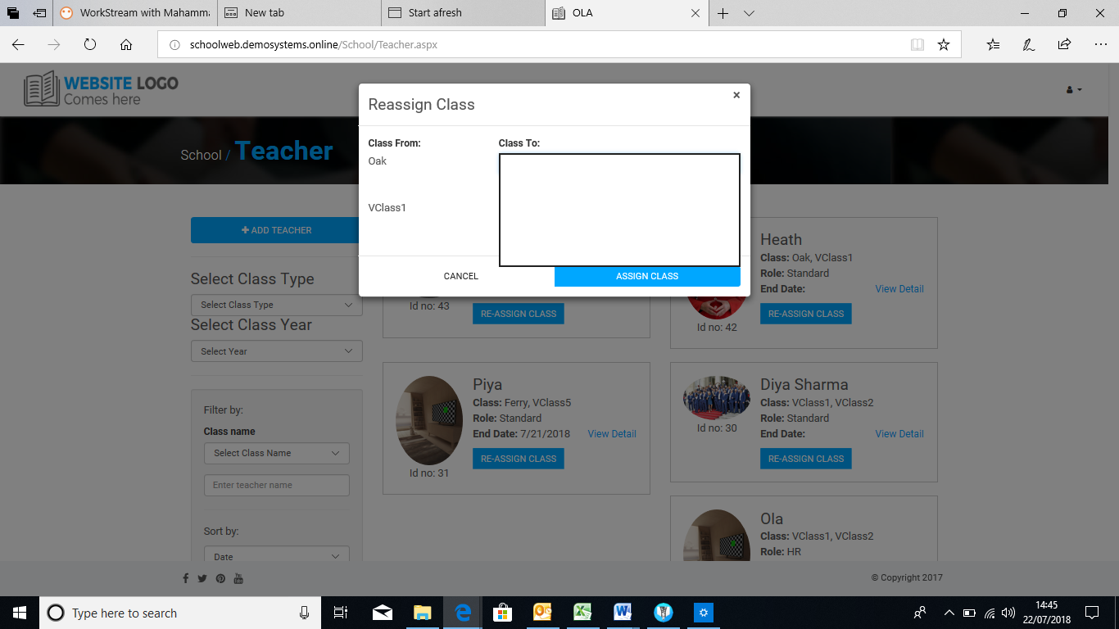

**Create Teacher**

* Remove Default Password. Teacher initial password should be system generated at setup - Done
* Role of “Standard” is seeded and it is the default. Other Setup Roles will have standard functionalities and the additional functionalities setup for the role – I am not able to test this
* Require fields should be indicated on the “Create” forms. This should be applicable to all forms across the website - Done
* Phone Number validation should allow 0 Prefix -Done
* + and – buttons not working for adding class to a Teacher -Done
* Only one class is required to be assigned before a Teacher can be created -Done

**STUDENT**

**Create Student**

* Name, Student ID and First Parent details are mandatory. Please highlight this. - Done
* Remove “Class” dropdown field - Done
* Remove Adding Pictures from “School Admin”. Only parent can add images – Done

**Edit Student**

* Remove Button Should Clear All the Parents Entries. However, you cannot UPDATE without entering mandatory fields (at least Primary Parents) - Done
* If Primary Parents is the one that is removed, Secondary Parents Entries BECOME Primary Parent Entries when Primary Parent Entries are cleared. -- Done
* Remove leading zeros validation of the Phone Number- Done
* Add button not working - Done
* “Secondary Parent Relation” is not dropdown. Please correct. - Done
* The Navigation should be Student and not Class -- Done

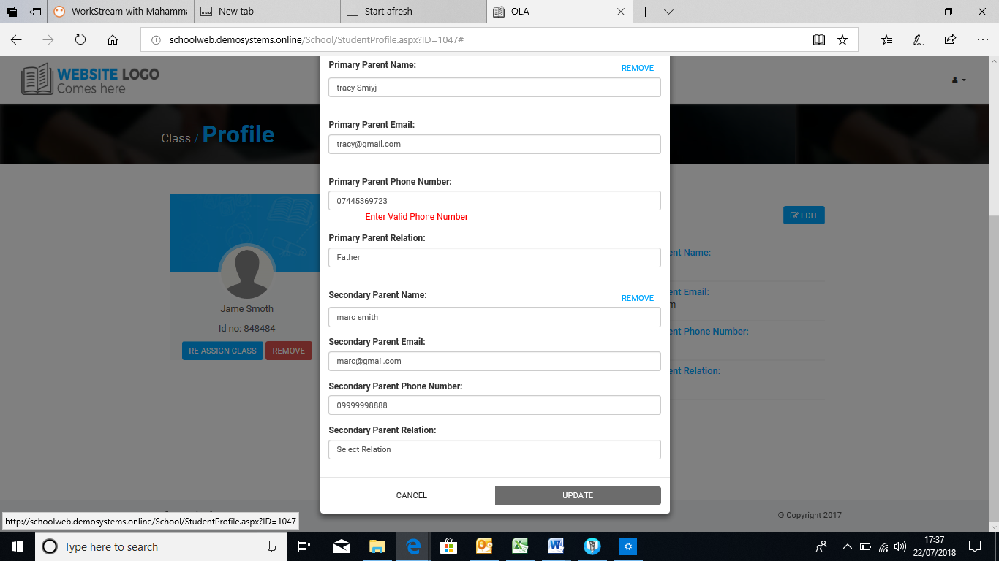

**BULK UPLOAD**

* This area need to be discussed in more details to include “Action” column, dropdown values

**SUPPORT**

**Support Summary Page**

* Move Create Button to the top - Done

**Support View Detail Page**

* Each detail message to have boundary, messaging user and time and date stamp – Date and Stamp is showing. However when I tested it, it did not show the message -- Done Now its Show Message
* The messages should be sorted in date descending i.e the latest message will be at the top - Done
* Add “Assign”, “Priority” and “Severity” to the support at the “ORGANISATION” module – Cannot be tested now. - Done
* The current design has a lot of white spaces at the side. Can we do something about it. - Done
* How will the design look with message that has attachments -- Done

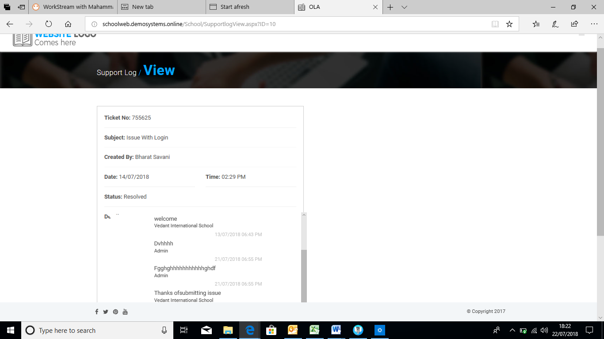

**PAYMENT**

* “Transaction Type”dropdown values should be changed as “Training”, Annual “Maintenance”, “Project”, “Starter Cost”, “Travel”, “Miscellaneous” – done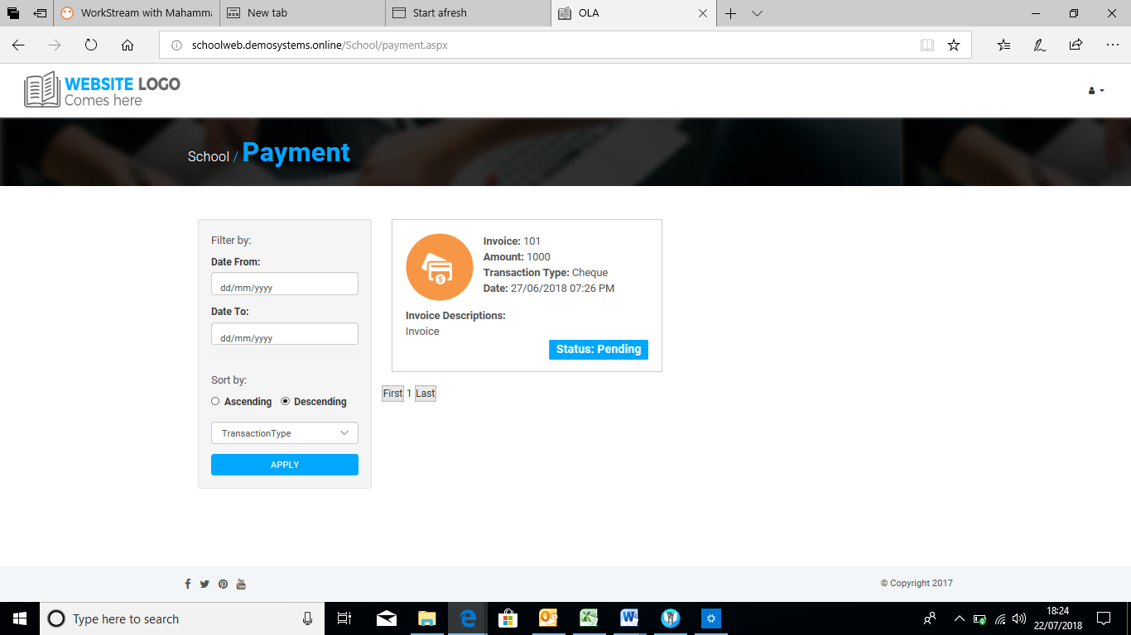

**REPORT**

I need to provide report and Report Parameters

**LOG ACTIVITY**

We need to add filter by “Log Name” and “Updated By” as dropdown. Will this be possible

**ADMIN**

* + Remove “Calendar” checkbox -Done

**PARENT**

MANAGE PICKER

**Manage Picker Page**

* Add “Phone Button” to the school for calling school phone number– Done
* Add Ability to Upload Student image on this page OR Child Page if it is better.
* Make “Picker Image” to POP-UP when clicked. This functionality should be assigned to all images - Done

**View Picker Page**

* Change “Manage Picker” button to “Manage All Pickers” - Done
* If there are no Pickers assigned. Show something like a text “No Picker Assigned Yet to Child”– Done
* Remove ability to upload Picker image
* Add ability to upload Student Image

**Add Picker Page**

* “Add Picker” should only list Pickers that are not yet assigned to the particular child – This should filter unassigned pickers for the child that you are viewing. At the moment, it filtering for the same for all children. Please correct.
* “Add” button on the “Add Picker” page should take us back to “View Picker Page” - Done

**Make Picker Today**

* Highlight the particular Picker and bring them to the top of the page – Done
* There can be only one “Picker Today” per child. At the moment, you can have more than one
* You can change “Picker Today” to another “Picker”. The systems should warn you with a meesage like “You have already make Pete Picker Today for Ashaka. Do you want to proceed?”. If yes, “Teresa” become “Picker Today” and “Pete” goes back to normal

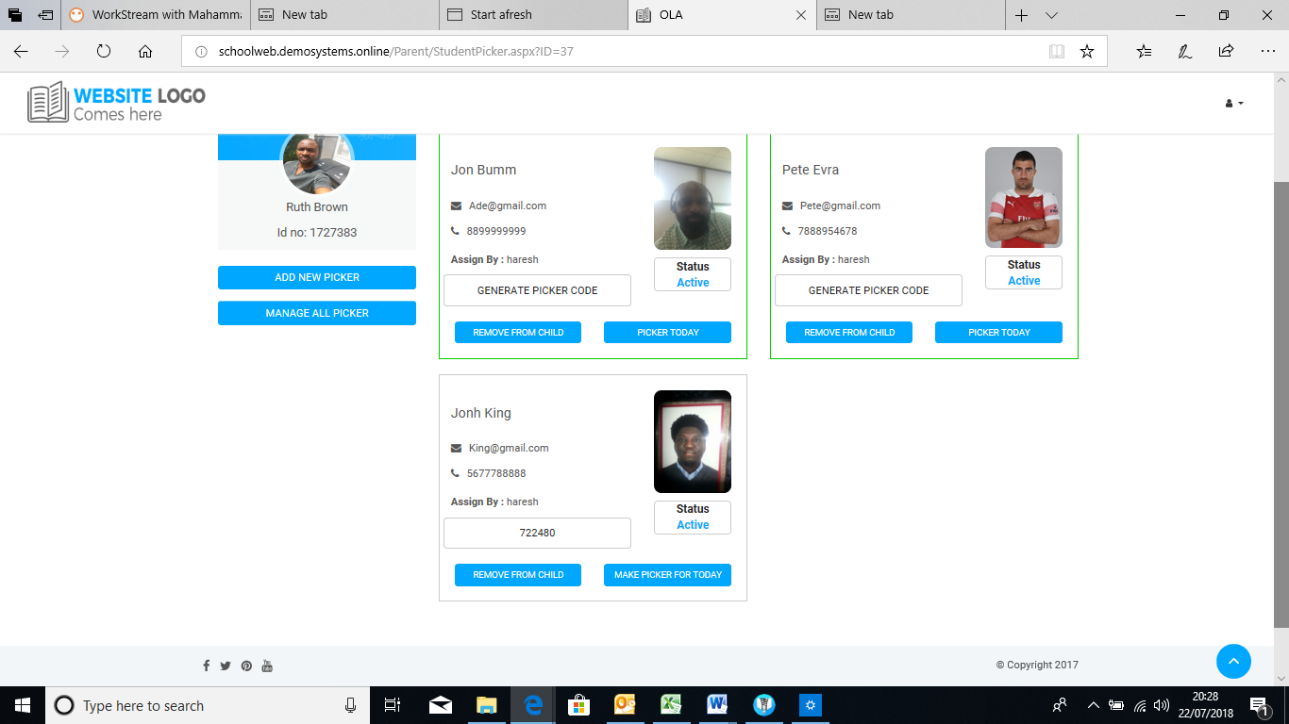

* All Pickers will still show at the “Teacher Module” but “Confirm Button” at the “Teacher Module” will not be available. Only to Picker Today. Please do not remove the “Confirm Button”. Just make it greyed out or give error message when used
* Add “Reset Picker Today” functionality or design so that when “Make Picker today” is picked, the existing one is reversed.
* All “Picker Today” is reverse to “Make Picker Today” at midnight Local time - Done

**InActive Slide**

* Only Pickers that are Active are shown at the “Teacher Module” for the child - Done
* Picker Active Status should change when the slide changes. It is not doing this at the moment. Please let it work for other major browsers like Microsoft Edge

**One-Off Button on Create Page**

* Create Picker and delete after 12 midnight

**Create Picker**

* Only First Name and Last Name are required fields. This need to be highlighted - Done
* Phone Number validation should allow first “0” - Done
* “Assign To” button should take us to “Edit Assignment Page” - Done
* “Submit” button should take us back to the “Manage Pickers Page”– Done

**DAILY PICKUP**

* Happy with the design? - Done

**MESSAGE**

* Introduce “Receiver Group” - Done
* Change the Dropdown of “Receiver” if “Teacher” to “Teacher Names” NOT “Parent Names” - Done
* Attachment button is not included in the message form - Done

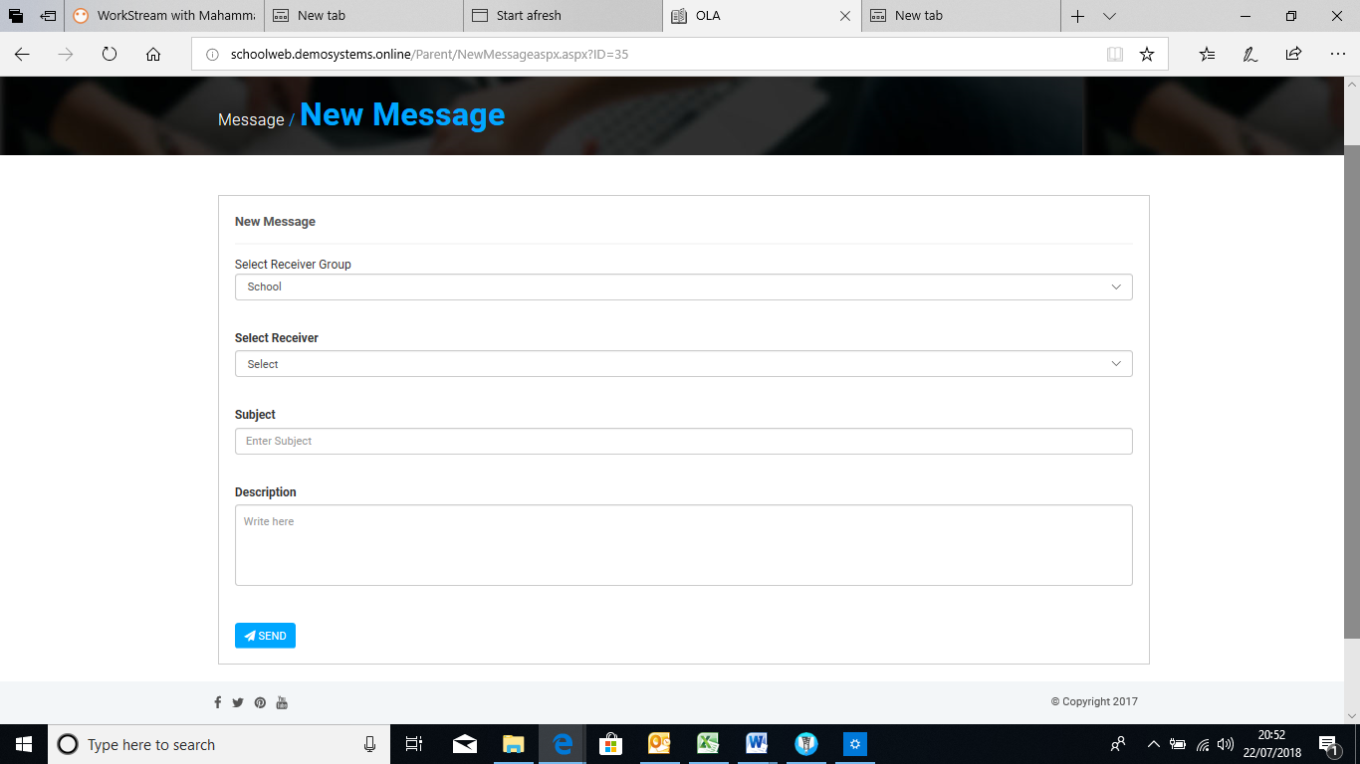

**TEACHER**

**Pickup Page**

* Date is text only and defaulted to “Today’s Date”. It cannot be changed. Pickup can only be conducted for today – Done

**Pickers Page**

* Only one of “Mark As Absent”, “Send to After School”, and “Send to Driver” can be selected at a time. Not at the same time. - DOne
* When any of “Mark As Absent”, “Send to After School”, and “Send to Driver” is selected

1. Pickup Status is updated
2. “Pickup” Page is load
3. Student is sorted to go to bottom of page

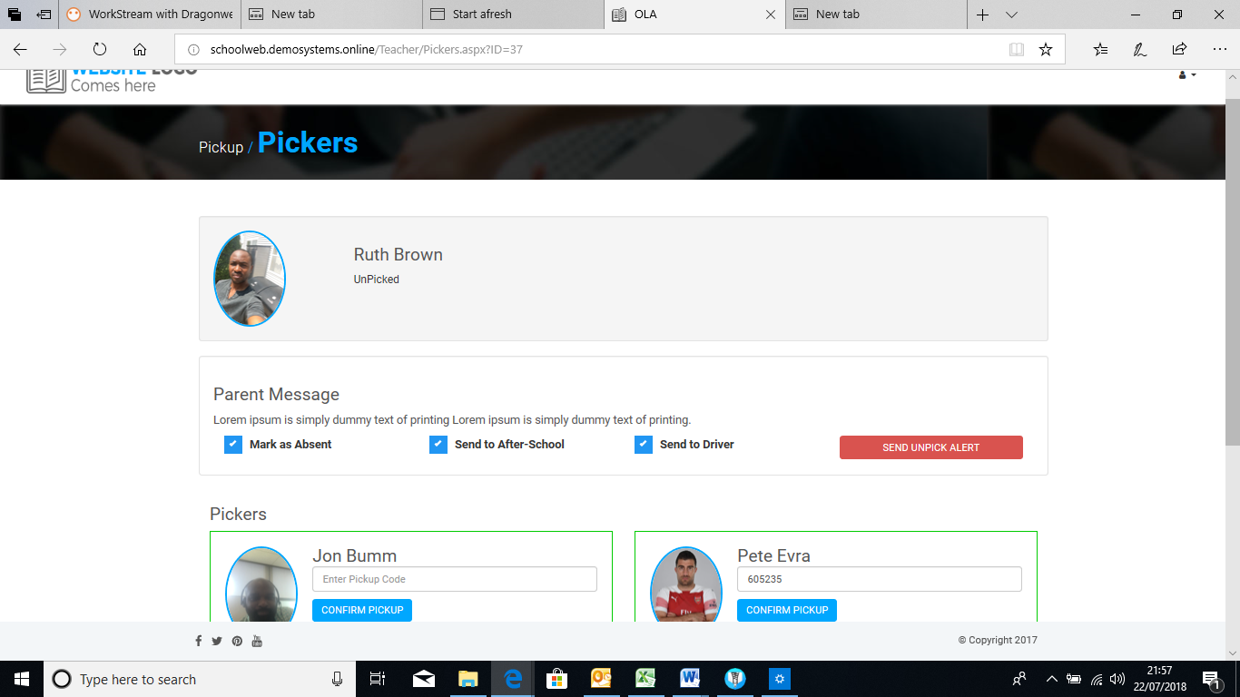

* If Child has no Picker, please show text “No Picker is assigned to this Child”. At the moment, it is showing nothing - Done

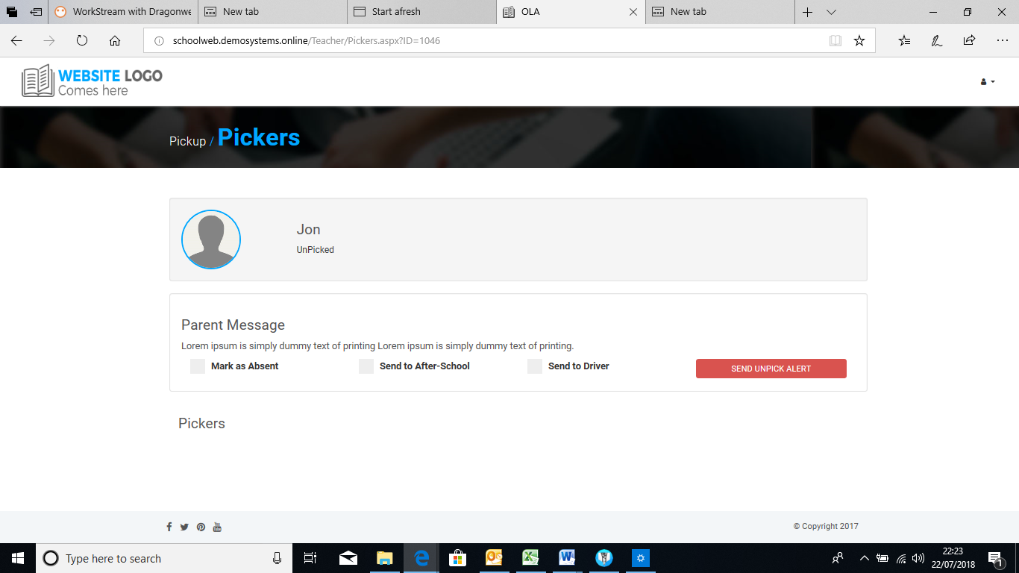

“Picker Today” picker is on top of the list and it is showing a text like “Picker Today” to highlight

* Put (Picker Today) in bracket after the name of “Picker Today”
* All the Confirm Pickup for other picker is greyed out when “Picker “Today” is activated for on Picker. Please do not “Remove Confirm Button”
* Codes generated by Parent should not be shown to the Teacher. It should be typed in
* Confirm Pickup can pick clicked for Pickers with Picture WITHOUT a code. Picker with no Picture NEED a code for 30 Days
* When “Confirm Pickup” is selected,

1. Pickup Status is updated
2. “Pickup” Page is loaded
3. Student is sorted to go to bottom of page

**Student Pickup Report**

* Display Last 30 Days and allow users to use Filter or Load More to check data that are older say 2 years ago (If required)

**Attendance Page**

* Date is text only and defaulted to “Today’s Date”. It cannot be changed. Pickup can only be conducted for today - DOne

**Class Attendance Report Page**

* When the page is opened, ”Attendance Report Date” should default to Attendance for Today and it should be displayed. User can then change to other days.
* The page scrolling is not working - Done

**Student Attendance Report**

* Attendance Report for the student should be sorted with Date Descending. The latest one should be at the top - Done